*SOFTWARE REQUIREMENT SPECIFICATION*

*AGRIPRO-*

**Document ID:** Agripro_srs_2.0.docx

**Author(s):** THIANESH G

**Version:** 2

**Date:** April 6, 2024

1. Objective and Scope --------------------------------------------------------------------- 3
2. Intended Audience ----------------------------------------------------------------------- 3
3. Functional Requirements --------------------------------------------------------------- 4
   1. Login -------------------------------------------------------------------------------- 4
   2. Sign in ------------------------------------------------------------------------------ 4
   3. Options page --------------------------------------------------------------------- 4
   4. Buy page --------------------------------------------------------------------------- 5
   5. Sell page --------------------------------------------------------------------------- 5
4. Non-functional Requirements --------------------------------------------------------- 5
   1. Hardware Requirements ------------------------------------------------------- 5
   2. Software Requirements -------------------------------------------------------- 5
   3. Scalability -------------------------------------------------------------------------- 5
5. Diagrams ------------------------------------------------------------------------------------ 6
   1. Class diagram --------------------------------------------------------------------- 6
   2. Use case diagram ---------------------------------------------------------------- 6
   3. Flow chart -------------------------------------------------------------------------
6. **Objective and Scope:**

The objective and scope of the project is to create an online platform where the end users will be able to view and buy farming tools and equipment. And additionally, they should be able to enquire about the product to the seller or manufacturer.

**Basic features of the project:**

If I open the site a login page should be displayed. If the user is new, he should be navigated to sign up page or he should enter the credentials and proceed with the login.

Once logged in he should be given with two options namely, 1.BUY and 2. SELL. Based on the user’s choice he should be navigated to the buy products or sell products page.

If the user’s choice was to BUY products he would be navigated to a page where he can find multiple products to choose from and he should be able to enquire about the product to the seller.

Once the user finalizes his product and then once he clicks the buy button, he should be taken to the payments page and he should be able to enter his payment details and make payment.

If the user’s choice was to SELL the product, he should be asked about the product he is selling and price he is going to sell at and photos of his product to showcase in BUY page.

1. **Intended Audience:**

This project’s most of the end users would be either farmers or farming product manufacturers.

Either way they both will be related to farming. So, the UI should not be complicated and should be simple.

1. **Functional requirements:**

**3.1. Login:**

Once the user enters the site, he should be asked with the login credentials. Which includes,

Username: Minimum of 8 characters without any spaces.

Mail id: Complete mail id which should contain the domain after ‘@’.

Password: Minimum of 8 characters at least one (special character, number, capital letter) should be present. Should not be a common password.

There should be an option for new users and users who forgot their password.

**3.2. Sign in:**

If the user is new to the page he should be asked to provide and verify his details which includes,

First name: Should only contain letters and no space at the end.

Last name: Should only contain letters.

Username: Minimum of 8 characters without any spaces.

Mail id: Complete mail id which should contain the domain after ‘@’.

Password: Minimum of 8 characters at least one (special character, number, capital letter) should be present. Should not be a common password.

Repeat password: should be same as the previous column.

Once he filled the details, he should press register and he should be able to enter into the site.

**3.3. Options page:**

Users should select between the given two options.

1. BUY PRODUCTS
2. SELL PRODUCTS

**3.4. Buy page:**

In this page all the available products in the market or the page should be shown along with the price and the seller’s details to enquire about the product.

If the user selects a product, there should be an option to buy the product.

After clicking “BUY” he should be taken to a payment portal. Where, he will select the mode of payment complete the transaction.

**3.5. Sell page:**

In this page, the user will be asked about the details of the product

1. Name,
2. Type of the product,
3. Price,
4. MFD,
5. Fuel type (optional): Petrol, Disel, Electric,
6. Photos,
7. Phone number for enquiry.
8. **Non-Functional requirements:** 
   1. **Hardware requirements:**

Smart phone or a computer which supports a browser and should have internet or Wi-Fi options.

* 1. **Software requirements:**

Web browser which has all the necessary features upto date.

* 1. **Scalability:**

A minimum of 100 users should be able to access the site simultaneously without any lag in the page.

1. **Diagrams:** 
   1. **Class diagram:**

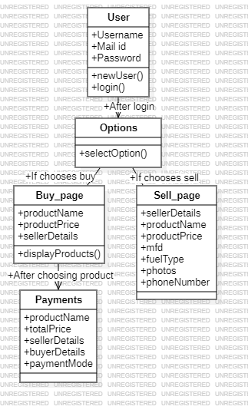

* 1. **Use case diagram:**

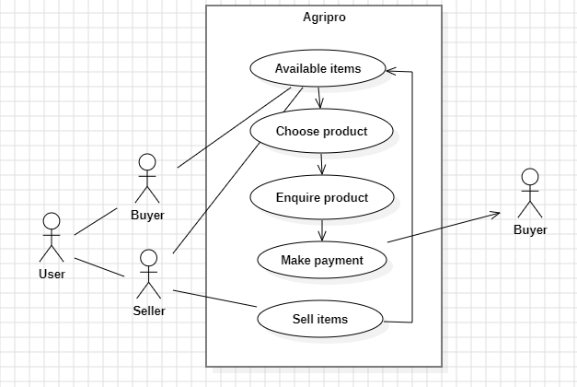

* 1. **Flow chart:**

